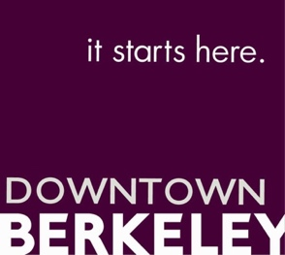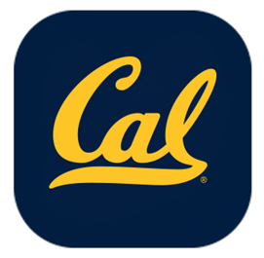

FOR IMMEDIATE RELEASE
Matthew Jervis
Director of Vitality
510.549.2230 x4
mjervis@downtownberkeley.com

Kick-Off Party for the Cal Football 2019 Season In the Downtown Berkeley Plaza
Co-hosted by Downtown Berkeley Association and Cal Athletics Friday, August 30th 5pm-7pm

(Berkeley, CA) — The Downtown Berkeley Association and Cal Athletics are co-hosting the 2019 Cal Football
Season Kick Off Party in the Downtown Plaza on Friday, August 30 from 5-7 p.m.
The evening will be filled with Cal give-a-ways, fun photo ops, the Cal Marching Band, guest speakers from Cal Athletics and the City of Berkeley and the Cal Dance Team, and of course, Oski will be making an appearance!
5:00pm: The Cal Marching Band, along with the Cal Dance Team, play their way down Center Street to the Plaza.
5:30pm: Cal Athletic Director Jim Knowlton and City of Berkeley Councilperson (and Cal Grad) Rigel Robinson will address the crowd.
6:00pm -7pm: DJ O’ Aces takes the stage along with more from the Cal Dance Team
According to John Caner, DBA, CEO, “Activating our Downtown Plaza with some Cal Football spirit is the perfect way to usher in a new school year and a new football season! Go Bears!”
“Being able to bring the spirit of Cal football to Plaza in the heart of Downtown Berkeley is a such great opportunity for Cal students and Cal Football fans to be part of their Downtown community!” Joe Mulford, Senior Associate Athletic Director, Cal Athletics

The Cal football season kicks off on Saturday, Aug. 31 when the Golden Bears host UC Davis at 3:30 p.m. in California Memorial Stadium. Fans are invited to get their day started at Tailgate Town on Maxwell Family Field starting at 1:30. For tickets to the opener and any of Cal’s other five home games, visit CalBears.com/tickets or call (800) GO BEARS (462-3277) and press option 3.
The Downtown Berkeley BART Plaza
The $13M renovation of Downtown Berkeley BART Plaza opened to great fanfare in October 2018, and features public art, commerce, and regular live music Berkeley LIVE! stage and state-of-the-art Meyers Sound system. You can learn more plaza programing at https://ontheplaza.downtownberkeley.com/

About the Downtown Berkeley Association (DBA)
The DBA is a nonprofit membership organization and the Owner’s Association for Downtown Berkeley’s Property-Based Business Improvement District (PBID), representing 221 property owners and approximately 703 of their merchant and business tenants in a 30-block area of Downtown Berkeley, bounded by Delaware to north, Carleton to the south, Grant to the west and Oxford to the east. Visit downtownberkeley.com for more information.

Cal Athletics
Cal Athletics supports 30 intercollegiate sports supporting 850 student-athletes. The Golden Bears have captured 97 team national championships, and athletes and coaches have won more than 200 Olympic medals.
###

