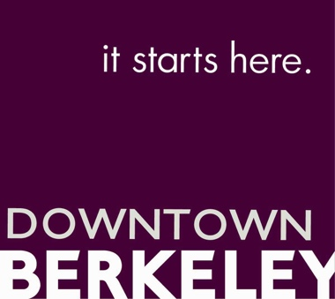

FOR IMMEDIATE RELEASE
June 11, 2019

Matthew Jervis
Director of Vitality
510.549.2230 x4
mjervis@downtownberkeley.com

DOWNTOWN BERKELEY KICKS OFF HISTORIC PRIDE WEEKEND
Drag Show, Queer Contra Dance, & Mya Byrne Concert
Thursday, June 27, 5-8pm
Downtown Berkeley BART Plaza, Shattuck & Center

(Berkeley, CA) — The Downtown Berkeley Association is hosting its very first PRIDE Weekend event on Thursday, June 27, 5:00-8:30pm in the new Downtown Berkeley BART Plaza.
This event is FREE for all ages and open to the public. Details are as follows:
- 5:00pm Downtown Berkeley’s PRIDE Drag Show
- 6:15pm Circle Left and Gender Neutral Contra Dancing
- 7:30pm Live music by Mya Byrne and the Something Extra
According to John Caner, CEO of Downtown Berkeley Association, “This is a historic PRIDE weekend, marking the 50th anniversary of the Stonewall riots in New York City. While we recognize most of the action will be in SF and NYC, we thought we would start the weekend early in Berkeley, and bring some fabulous queer joy and creativity to our new BART Plaza!”
5:00 The event begins with very first Berkeley Pride Drag Show brings a fun and talented group of performers featuring:
- Chico Suave @chicosuave01
- Kel Dae @gender_repeal_party
- Sgt Die Wies @diewies
- Holden & Tanya with Caleb Arring @caleb.f2m
- Randy Puck
- Vera Hannush @veritas_22 on IG

6:15 immediately following the the drag performance, will be the Oakland based contra dance event Circle Left. Circle Left will take over the Plaza for their their very first outdoor dance event. Circle Left invites all ages, orientations, gender identities, and experience levels to participate.
7:30 The New York based Mya Byrne and the Something Extra finish up our PRIDE event with their unique brand of folk, blues, and country music performed on the Berkeley LIVE! Stage. According to Bandcamp, “Mya Byrne is a badass trans lady who will rock you!”

The DBA is delighted to be celebrating Downtown Berkeley’s very first PRIDE weekend with this amazing bill of talented performers and musicians.

The Downtown Berkeley BART Plaza
The $13M renovation of Downtown Berkeley BART Plaza opened to great fanfare in October 2018, and features public art, commerce, and regular live music Berkeley LIVE! stage and state-of-the-art Meyers Sound system. You can learn more plaza programing at https://ontheplaza.downtownberkeley.com/

About the Downtown Berkeley Association
Downtown Berkeley Association is a nonprofit membership organization and the Owner’s Association for Downtown Berkeley’s Property-Based Business Improvement District (PBID), representing 221 property owners and approximately 703 of their merchant and business tenants in a 30-block area of Downtown Berkeley, bounded by Delaware to north, Carleton to the south, Grant to the west and Oxford to the east. Visit downtownberkeley.com for more information, or follow us on Twitter and Facebook and Instagram.

###

